SUPPORTING INFORMATION

Species sensitivity distributions for use in environmental protection, assessment and management of aquatic ecosystems for 12,386 chemicals

Leo Posthuma^{1, 2, *}
Van Gils, J.³
Michiel C. Zijp ¹
Dik Van de Meent ^{2,4,5}
Dick De Zwart ^{4,5}

Running head:
Species Sensitivity Distribution models for 12,386 compounds

Addresses and affiliations
¹ National Institute for Public Health and the Environment (RIVM), Centre for Sustainability, Environment and Health, P.O. Box 1, 3720 BA Bilthoven, the Netherlands. E: Leo.Posthuma@rivm.nl, T:+31-30-2742295;
² Radboud University, Department of Environmental Science, Institute for Water and Wetland Research, Faculty of Science, Radboud University, Nijmegen, The Netherlands;
³ Deltares, P.O. Box 177, Delft, The Netherlands
⁴ Mermayde, Groet, the Netherlands
⁵ ARES, Odijk, the Netherlands

* Corresponding author. To whom correspondence may be addressed.

Supporting Information - Section 1.

Use of SSDs.

SI-Table 1. Non-limitative set of examples of the use of results of SSD-modeling in contemporary environmental protection, assessment and management.

Context | Assessment focus | Formal adoption | Examples of the use of SSDs | Literature (examples, non-limitative)
Regulatory  Target: protective | Prospective risk assessment of individual chemical substances | Yes | EU-Derivation of HCp (Hazardous Concentration for p% of the species) to define a protective benchmark concentration, which underpins proposals for a regulatory-adopted protective benchmark concentration (e.g., EU-PNEC-Predicted No Effect Concentration) | Guidance document EU-REACH (ECHA 2016)  Guidance document EU-WFD (EC 2011)
 |  | Yes | Ibidem, resulting in EU-RAC (Regulatory Acceptable Concentration) | Guidance document EU-Plant Protection Products Regulation (EFSA 2013)
 |  | Yes | US-Ibidem, resulting in US-Numerical National Water Quality Criteria for the protection of aquatic organisms | Guidance document US-EPA (Stephan et al. 1985)
 |  | Yes | Global, Ibidem, various jurisdictions and various specifications on SSD-data selection and model use | e.g., OECD-countries (OECD 1995), Canada (CCME 2007), Australia and New Zealand (ANZECC ARMCANZ 2000),
 |  | Yes or No | Ibidem, some scientific publications from various countries on SSD-derived benchmarks | China (Yin et al. 2003), Costa Rica (Rämö et al. 2016), Ethiopia (Teklu et al. 2016), Japan (Nagai 2016), Russia (Shikitov 2016), South Africa (Wepener et al. 2006)
Summary current status: global use, SSD-data and model requirements dependent on jurisdiction; often NOEC-type ecotoxicity data and a lower-percentile of SSDs are selected to derive regulatory protective benchmarks. The number of compounds for which this formally is applied is commonly few tens.
Societal and regulatory concern: many current and emerging chemicals lack a protective benchmark.
Regulatory, environmental quality assessment | Prospective or retrospective environmental risk assessment | Yes | Evaluating and expressing environmental quality (pollution) defined as ratio of predicted or measured concentration and the benchmark, resulting in Risk Quotients (RQ, see protective uses of SSDs) | All formally adopted examples of the previous category of SSD uses, where regulatory benchmark based on SSDs are used to quantify RQs per compound and sum-RQ for mixtures; RQ>1 is interpreted as insufficient protection
 |  | Yes | EU-Ibidem, large-scale quality status assessments: e.g., European surface waters | Reporting on the status of European surface waters under the Water Framework Directive (EEA 2012)
 |  | Yes or No | Ibidem, some scientific publications from various countries on SSD-derived predicted impact assessments (often using toxic pressure, expressed as (multi-substance) Potentially Affected Fraction, as metric of severity of pollution | First example: (Posthuma 1992); Definition and soil quality example: (Van Straalen and Denneman 1989); US-wide pesticide example (Solomon et al. 1996; Solomon et al. 2013), followed by current global examples (e.g., impacts of oil production in marine environment (Parkerton et al. 2017), prioritization of chemical groups driving adverse effects (Munz et al. 2016), spatial mapping of mixture risks (Carafa et al. 2011; Wijdeveld et al. 2018), disentangling mixture impacts in multi-stressor context (Posthuma et al. 2016), and many more
 |  | No | Aggregating toxic pressure results into Chemical Footprints for an area | Definitions and examples (Zijp et al. 2014), (Bjørn et al. 2014).
 |  | Yes | Assessment of expected impact perimeter of incidental emissions and disasters, based on median of EC50 distribution | The UN-Flash Environmental Assessment Tool, for impacts on ecosystem integrity (Posthuma et al. 2014)
Summary current status: global use, partly formal (and in those cases RQ-ratio’s dependent on the criteria for the regulatory use of SSD as in the above category of SSD-use formats), partly to refine impact insights as compared to the RQ (for compounds) and summed RQ (for mixtures) approaches in environmental quality assessment. The number of compounds for which this currently applies: commonly few tens to hundreds.
Societal and regulatory concern: many current and emerging mixture pollution situations are identified by RQ>1 (implying insufficient protection), while no insights can be derived on the probability and magnitude of expected impacts (for a discussion see: (Posthuma et al. 2008)).
Life cycle impact assessment of products and services | Production process ecotoxicity hotspots | Yes | Industry: deriving the midpoint-indicator on ecotoxicity for a production process to establish production-chain hotspots (with highest ecotoxicity consequences), to enable reduction of the production environmental footprint | UNEP-consensus model USETox (Rosenbaum et al. 2008)
 | Product comparison | Yes | Industry/Consumer: deriving the midpoint-indicator on ecotoxicity and inform consumers (industry), to reduce environmental footprint of consumption (consumer choice) | UNEP-consensus model USETox (Rosenbaum et al. 2008)
 | EU-PEF and OEF | Pending | EU Ibidem, EU-Product and Organisation Environmental Footprinting | Over-all status PEF-OEF Guidances: accepted (EC 2017; 2018)  Ecotoxicity indicator: technical developments ongoing (Saouter et al. 2017), (Saouter et al. 2018), with recent reporting of novel effect factors (status December, 2018)
Summary current status: global use in the format of the USEtox UNEP-SETAC consensus model for ecotoxicity in LCIA. Swift developments ongoing, regarding update on the USEtox-model (modelling approach) as well as coverage of compounds, substantiated by various reports and publications (Müller et al. 2016; Saouter et al. 2017; Saouter et al. 2018) and by the present study.
Societal and regulatory concern: for many products and services, the ecotoxicity indicator is considered a key part of the EU PEF and OEF approaches, with ongoing international alignment of global consensus approaches for data selection and SSD derivation.

Supporting Information - SECTION 2.

characteristics of the ecotoxicity data set.

Records in the collated and curated data set.
When stripped from repetitive data, the set of measured ecotoxicity data consists of 256,409 records on 11,126 different substances, where 123,630 records pertain to acute EC50 test results, 75,131 to acute NOEC values, 8,404 records cover chronic EC50 values and 49,244 records reflect chronic NOEC values.

In total, 2,257 different taxa have been subjected in a test to one or more substances. The number of different taxa tested per substance and test endpoint ranges from 1 to 271.

The addition of the read-across data with estimates of acute EC50 values for green algae and/or daphnids and/or fish, adding 15,273 data records.

The combined SSD-derivation approaches brought the number of different substances with information on ecotoxicity to 12,386 (as some compounds have both a data-driven and a read-across SSD).

Of the 271,682 data records 25% are based on validated data from existing ecotoxicity databases (‘strictly measured’ and referenced) and 69% are based on untraceable and unreferenced REACH data, while 5% are based on read-across data.

Supporting Information - SECTION 3.

tabulated SSDs and their quality scores

SI-Table 2. Basic information on the characteristics of Species Sensitivity Distributions for 12,386 substances to be used in the context of assessments geared towards chemical- and environmental risk assessments and life cycle assessments of products and services is available through an excel file in the figshare link below. The associated excel file contains an explanation of the abbreviations used in the data table, as well as an overview of the number of SSDs per quality code.

INSERT EXCEL TABLE LINK HERE:
Data pertaining to this manuscript are deposited in figshare at DOI:xxxx.

Figshare should contain the excel file: “20190114 mu&Sigma SSD Supplemental Info Acute and Chronic.xlsx”

Supporting Information - SECTION 4.

summary of exposure information for the case study.

Approaches.
Choice of chemicals. Chemicals considered in the case study (REACH-chemicals, pesticides and pharmaceuticals) have been or are produced, used and emitted in Europe (based on available dossier information), and have sufficient data for all analysis steps.
Production and emission data. The companion paper (Posthuma et al. 2019, companion paper, submitted Sept 2018, presently under revision) describes the collection of production data for > 6000 compounds, and the derivation of emitted mass fractions.
Derivation of exposure concentration. An integrated model framework was used to combine emission data, fate processes and hydrological conditions (influenced by weather data) to provide predicted environmental concentration (PEC) data (Van Gils et al. In preparation, 2019). This modeling is based on the E-HYPE hydrology model (Donnelly et al. 2013), on which the emission data were projected.
Subselection of substances. For the case study, a subset of 1760 substances was selected to represent substances with adequate physico-chemical, as well as ecotoxicological data availability.
Validation of predicted and observed concentrations. To evaluate accuracy, predicted concentrations were compared to measured concentrations in five different European regions (Danube region, Rhine region, Swiss region, Spanish region and Swedish region). Details on the integrated modeling of water concentrations will be published by Van Gils et al. (In preparation, 2019).

Results
Number of PECs. The modeling framework was used to predict freely dissolved concentrations for 22,278 EU sub-catchments (median spatial resolution: 214 km2) for a 365 day period in the year 2013. The total number of PECs was 1.4 * 10¹⁰ (22,278 sites * 365 days * 1,760 compounds).

PEC variation. Exposure differences for chemicals amongst sites in Europe span various orders of magnitude. These exposure data were used as basis for the impact assessments of the case study.

Validation. The accuracy evaluation of the simulated concentrations could be performed for 146 substances in the available regional datasets. Altogether 226 substance/region combinations could be evaluated.
The differences between modelled and measured concentrations were calculated as log(${\overline{C}}_{m}/{\overline{C}}_{f}$), where ${\overline{C}}_{m}$ denotes the average simulated P95-year concentration for the region and ${\overline{C}}_{f}$ the average observed concentration in the same region. SI-Figure 1 shows the histogram of factorial difference between modeled and measured concentrations obtained for 226 substance/region combinations.
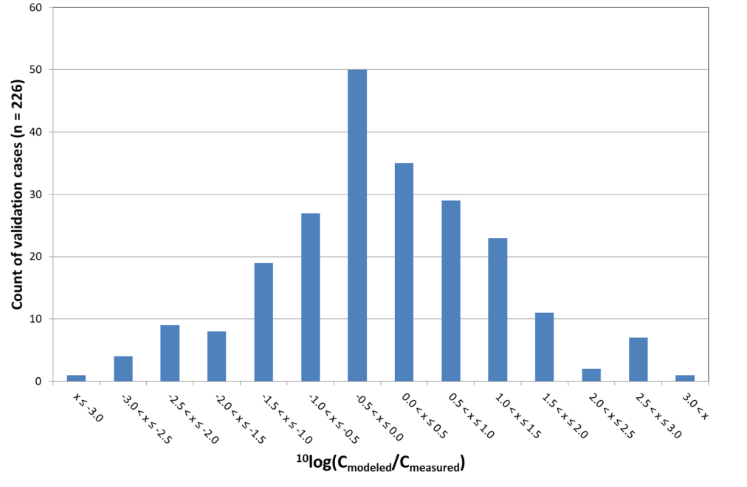
SI-Figure 1. Histogram of factorial difference between modeled and measured concentrations for the 226 substance/region combinations used for model validation.
Overall, the average factorial difference is approx. zero and the standard deviation is 1.2. In 65% of cases the difference is within -1 and +1 (one order of magnitude error), while in 90% of cases the difference is within -2 and +2 (two orders of magnitude). These results should be interpreted in the context of the wide spatio-temporal variation of measured field concentrations that result from natural processes, human activities (pesticide spraying) and sampling schemes.

Supporting Information - SECTION 5.

Illustration of alternative data analysis choices.

The main text of the manuscript illustrated impact rankings based on P95-year mixture toxic pressure data. It was noted that peak exposures (e.g., of pesticides) that last for less than 18 days (any exposure duration between 1 and 17 days) are missed. That is, pesticides will be under-represented in the ranking of relative impacts for the P95-data, due to the assessors’ choice for P95-data.

Below we illustrate the change of probabilities of exceedance of no-effect and 50%-effect levels, respectively, comparing P95 and P99 based assessments.

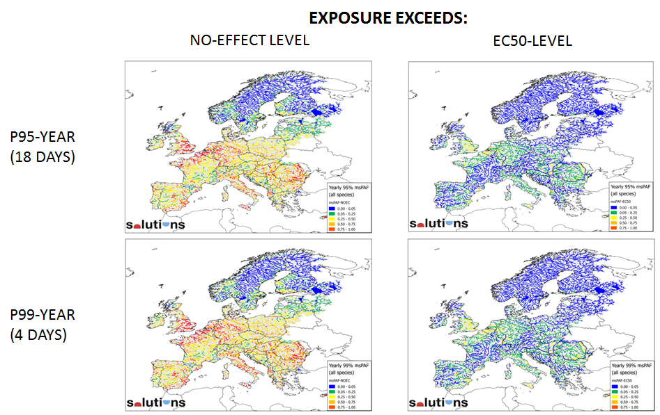

Close inspection of the maps, summarized as distributions of exceedance probabilities over the 22,278 sites (shown below), shows the difference of selecting different percentiles for exposure time.

P99 mixture toxic pressures are higher than P95 pressures. That is, peak exposures (between 1 and 4 days) impact a higher fraction of species. The probability to exceed the 50%-effect level increases e.g. for site-rank 20,209 from approx. 20% to nearly 30%.

Accounting for peak exposures results in different calculated impacts, and thus in different site and compound rankings between P95 and P99 assessments.

This implies that assessors should tailor their data analysis steps to the situation under investigation when possible, to avoid a numerically correct ranking (P95 and P95) of which one is a better approximation of the risks one might want to prioritize and manage. Given the vastly different emission-impact pathways of chemical groups, these considerations may also lead to a separate ranking within the group of pesticides, industrial chemicals or pharmaceuticals. This provides information for management prioritization within a more homogeneous set of problems, involving specific sets of stakeholders and related to specific types of solutions.

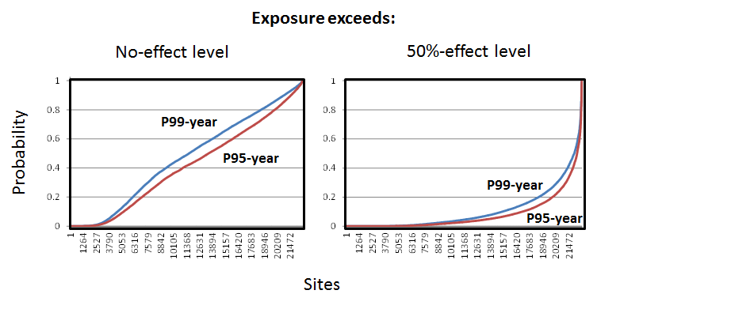

Supporting Information - SECTION 6.

Characteristics of top-15 chemicals in the case study

Use characteristics
The top-15 compounds – with the two forbidden compounds removed from further analyses here – are all widely used in agriculture, or by consumers and professionals as well as in various industrial processes.

Hazard classifications
The compounds are all classified as “toxic to aquatic life with long lasting effects”, as “very toxic to aquatic life / very toxic to aquatic life with long lasting effects”, and/or as Substances of Very High Concern, based on chemical safety assessments.

Import- and production mass ranges
Their range of import and production masses in the EU is very high across the group of substances examined (for example, 10⁶ to 10⁷ tons per year for bisphenol-A, and 10 to 100 tons per year for difenylamine).

SUPPORTING INFORMATION - REFERENCE LIST

ANZECC ARMCANZ. 2000. Australian and new zealand guidelines for fresh and marine water quality. Canberra, ACT, Australia: Australian and New Zealand Environment and Conservation Council and Agriculture and Resource Management Council of Australia and New Zealand.
Bjørn A, Diamond M, Birkved M, Hauschild MZ. 2014. Chemical footprint method for improved communication of freshwater ecotoxicity impacts in the context of ecological limits. Environmental Science and Technology. 48(22):13253-13262.
Carafa R, Faggiano L, Real M, Munné A, Ginebreda A, Guasch H, Flo M, Tirapu L, der Ohe PCv. 2011. Water toxicity assessment and spatial pollution patterns identification in a mediterranean river basin district. Tools for water management and risk analysis. Science of The Total Environment. 409(20):4269-4279.
CCME. 2007. A protocol for the derivation of water quality guidelines for the protection of aquatic life. . Winnipeg, Canada: Canadian Council of Ministers of the Environment. .
EC. 2011. Common implementation strategy for the water framework directive (2000/60/ec) - guidance document no. 27 - technical guidance for deriving environmental qualilty standards. Brussel, Belgium.
EC. 2017. Pefcr guidance document, - guidance for the 13 development of product environmental footprint category rules (pefcrs), version 6.3, december 14 2017.
EC. 2018. Oefsr guidance document, - guidance for the 10 development of organisation environmental footprint sector rules (oefsrs), version 6.3, january 11 2018.
ECHA. 2016. Guidance on information requirements and chemical safety assessment, chapter r.16: Environmental exposure assessment. Version 3.0. European chemicals agency, report echa-16-g-03-en, helsinki. February 2016.
EEA. 2012. European waters - assessment of status and pressures. Copenhagen, Denmark: European Environment Agency. No. 8/2012.
EFSA. 2013. Guidance on tiered risk assessment for plant protection products for aquatic organisms in edge-of-field surface waters. . EFSA PPR Panel (EFSA Panel on Plant Protection Products and their Residues).
Müller N, de Zwart D, Hauschild M, Kijko G, Fantke P. 2016. Exploring reach as potential data source for characterizing ecotoxicity in life cycle assessment. Environmental Toxicology and Chemistry.n/a-n/a.
Munz NA, Burdon FJ, de Zwart D, Junghans M, Melo L, Reyes M, Schönenberger U, Singer HP, Spycher B, Hollender J et al. 2016. Pesticides drive risk of micropollutants in wastewater-impacted streams during low flow conditions. Water Research.
Nagai T. 2016. Ecological effect assessment by species sensitivity distribution for 68 pesticides used in japanese paddy fields. Journal of Pesticide Science. 41(1):6-14.
OECD. 1995. Guidance document for aquatic effects assessment.: Organization for Economic Cooperation and Development, Paris, France.
Parkerton TF, Bok M, Ireland AW, Prosser CM. 2017. An evaluation of cumulative risks from offshore produced water discharges in the bass strait. Marine Pollution Bulletin.
Posthuma L. 1992. Genetic ecology of metal tolerance in collembola. Vrije Universiteit.
Posthuma L, De Zwart D, Van de Meent D. 2019, companion paper, submitted Sept 2018, presently under revision. Screening level estimation of release rates of currently used chemicals to the environment - application to solution-oriented assessment of impacts on aquatic ecosystems Environmental Toxicology and Chemistry.
Posthuma L, Dyer SD, de Zwart D, Kapo K, Holmes CM, Burton Jr GA. 2016. Eco-epidemiology of aquatic ecosystems: Separating chemicals from multiple stressors. Science of The Total Environment. 573:1303-1319.
Posthuma L, Eijsackers HJP, Koelmans AA, Vijver MG. 2008. Ecological effects of diffuse mixed pollution are site-specific and require higher-tier risk assessment to improve site management decisions: A discussion paper. Science of the Total Environment. 406(3):503-517.
Posthuma L, Wahlstrom E, Nijenhuis R, Dijkens C, De Zwart D, Van de Meent D, Hollander A, Brand E, Den Hollander HA, Van Middelaar J et al. 2014. The flash environmental assessment tool: Worldwide first aid for chemical accidents response, pro action, prevention and preparedness. Environment International. 72(0):140-156.
Rämö RA, van den Brink PJ, Ruepert C, Castillo LE, Gunnarsson JS. 2016. Environmental risk assessment of pesticides in the river madre de dios, costa rica using perpest, ssd, and mspaf models. Environmental Science and Pollution Research.1-16.
Rosenbaum RK, Bachmann TM, Gold LS, Huijbregts MAJ, Jolliet O, Juraske R, Koehler A, Larsen HF, MacLeod M, Margni M et al. 2008. Usetox - the unep-setac toxicity model: Recommended characterisation factors for human toxicity and freshwater ecotoxicity in life cycle impact assessment. International Journal of Life Cycle Assessment. 13(7):532-546.
Saouter E, Aschberger K, Fantke P, Hauschild MZ, Bopp SK, Kienzler A, Paini A, Pant R, Secchi M, Sala S. 2017. Improving substance information in usetox®, part 1: Discussion on data and approaches for estimating freshwater ecotoxicity effect factors. Environmental Toxicology and Chemistry. 36(12):3450-3462.
Saouter E, Biganzoli F, Ceriani L, Versteeg D, Crenna E, Zampori L, Sala S, Pant R. 2018. Environmental footprint: Update of life cycle impact assessment methods – ecotoxicity freshwater, human toxicity cancer, and non-cancer. Luxembourg: European Union. ISBN 978-92-79-98182-1, doi: 10.2760/178544 No. JRC114227.
Shikitov VC. 2016. Ecotoxicology and statistical modeling the effect of using the r. Togliatti: The Russian Academy of Sciences Institute of Ecology of Volga Basin.
Solomon KR, Baker DB, Richards P, Dixon KR, Klaine SJ, La Point TW, Kendall RJ, Giddings JM, Giesy JP, Hall LWJ et al. 1996. Ecological risk assessment of atrazine in north american surface waters. Environmental Toxicology and Chemistry. 15(1):31-76.
Solomon KR, Giesy JP, Lapoint TW, Giddings JM, Richards RP. 2013. Ecological risk assessment of atrazine in north american surface waters. Environmental Toxicology and Chemistry. 32(1):10-11.
Stephan CE, Mount DI, Hansen DJ, Gentile JH, Chapman GA, Brungs WA. 1985. Guidelines for deriving numerical national water quality criteria for the protection of aquatic organisms and their uses. Duluth MN: US EPA ORD ERL. No. PB 85-227049.
Teklu BM, Retta N, Van den Brink PJ. 2016. Sensitivity of ethiopian aquatic macroinvertebrates to the pesticides endosulfan and diazinon, compared to literature data. Ecotoxicology.1-8.
Van Gils J, Schueder R, Chrzanowski C, Markus A, Cousins I, Lindim C, Focks A, Baveco H, Posthuma L, Kutsarova S et al. In preparation, 2019. An integrated model system for europe-wide assessment of the risks to ecosystems and human health of emerging pollutants. Environmental Toxicology and Chemistry.
Van Straalen NM, Denneman CAJ. 1989. Ecotoxicological evaluation of soil quality criteria. Ecotoxicology and Environmental Safety. 18:241-251.
Wepener V, Cyrus DP, Vermeulen LA, O’Brien GC, Wade P. 2006. Development of a water quality index for estuarine water quality management in south africa. No. WRC Report : 1163/1/06.
Wijdeveld AJ, Schipper CA, Heimovaara TJ. 2018. Variation in the availability of metals in surface water, an evaluation based on the dissolved, the freely dissolved and biotic ligand model bioavailable concentration. CATENA. 166:260-270.
Yin D, Jin H, Yu L, Hu S. 2003. Deriving freshwater quality criteria for 2,4-dichlorophenol for protection of aquatic life in china. Environmental Pollution. 122(2):217-222.
Zijp MC, Posthuma L, Van de Meent D. 2014. Definition and applications of a versatile chemical pollution footprint methodology. Environmental Science and Technology. 48(18):10588−10597.

